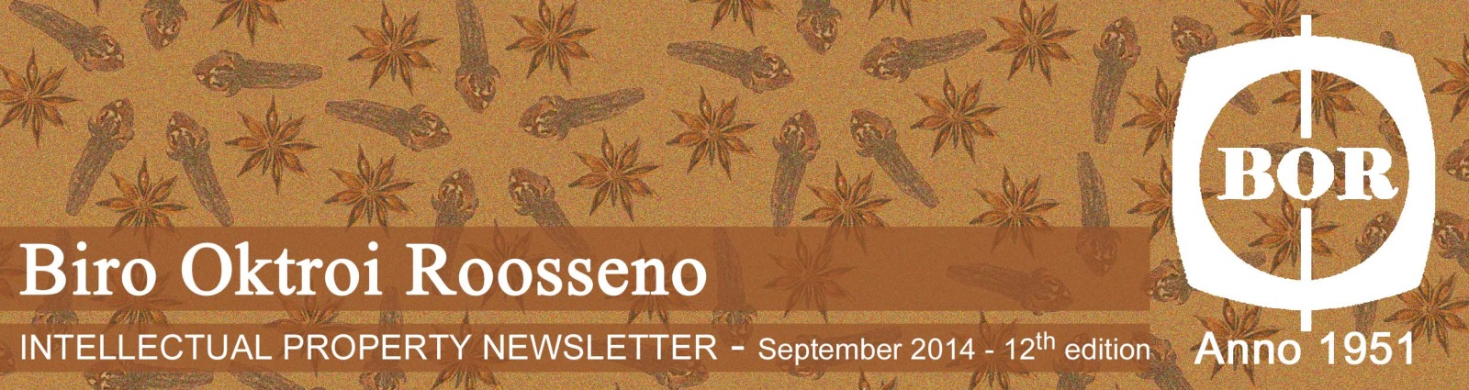
Biro Oktroi Roosseno
INTELLECTUAL PROPERTY NEWSLETTER – March 2018 – 26th Edition

This Edition Newsletter contains:
- IWAYA Trademark Dispute in Indonesia
- Felix Buhler Trademark Dispute
- PT. Sido Muncul Purchased Herb Trade Secret
- Madrid Protocol in Indonesia
- Indonesia to Implement Hague Agreement
- DGIP declares Geographical Indication year in Indonesia

- IWAYA Trademark Dispute in Indonesia
Iwaya Corporation from Japan, a manufacturer of toys, stationery, gift items, game machines which was established since 1923 and through the years they have been able to maintain the mark IWAYA in many countries around the world.
However, when Iwaya Corporation filed their well-known mark in Indonesia, they encountered a problem whereas a local Indonesian company has registered the mark IWAYA in Indonesia. This led the application by Iwaya Corporation Japan to be rejected.

Iwaya Corporation then filed a cancellation lawsuit to the Commercial Court of Central Jakarta, to cancel the local owned Iwaya mark. After the court hearings, the Commercial Court rendered their decision in favor of Iwaya Corporation Japan, whereas the rulings were:
- To declare that Iwaya Corporation Japan is the rightful owner of Iwaya mark in Indonesia for class 28;
- Iwaya is a well-known mark of Iwaya Corporation Japan;
- The local owned Iwaya mark registration was in bad-faith;
- To cancel the locally owned Iwaya mark registration.

www.amazon.com
This ruling once again proves that the Indonesian Judicial System has succeeded in protecting a well-known marks and an important signal to those who would like to invest their business in Indonesia that Indonesia is a proper place to invest.

- Felix Buhler Trademark Dispute
We might know that New York, Paris, Milan, and London have a significant influence on international fashion trends. These mega fashion capitals are places to aspire for the designers and people around the world.
Among the fashion capitals of Paris, Milan and London, we might realize Swiss as the fashion conscious. All major apparel trademarks are represented on the Swiss market. Swiss may not be the fashion capital of the world, but Swiss clothing marks represent an attractive and fashionable style for persons of every gender and age. Felix Buhler is one of the famous Swiss clothing products in various countries with excellent quality.
Felix Buhler trademark has been registered in Switzerland since the 1990s and also in several countries around the world.
In Indonesia, the Felix Buhler trademark filed to the Directorate of Trademarks, Directorate General of Intellectual Property on May 4, 2015 by Felix Buhler AG under agenda No. D002015018545. The trademark protects class 18 (leather accessories) and class 25 (clothing, footwear, headgear). However until recently the said registration by Felix Buhler is held back due to a similar trademark registration belonging to the local businessman, Sumpena Rahardja. Pursuant to this matter, Felix Buhler AG of Switzerland filed a cancellation lawsuit against the trademark registration of “Felix Buhler” by Sumpenan Rahardja to the Central Jakarta District Court. The dispute was registered under No.73/ Pdt.Sus Trademark / 2017 / PN. Jkt. Pst.

www.kramer.co.uk
The similarity occurs in the form of the use of the name Felix Buhler in the trademark used by Sumpena Rahardja, both in writing, visualization and pronunciation. In addition, the equation also occurs in the type of goods produced by “Felix Muhler” of Sumpena Rahardja.
The Defendant's trademark is registered under registration No. IDM000030238 on behalf of Sumpena Rahardja which protects the class 25 of goods. The Defendant’s trademark has been registered since September 8, 2003 and renewed on September 13, 2012. Currently, the decision on this case has yet been concluded.
- PT. Sido Muncul Purchased Herb Trade Secret

http://sidomuncul.id/
One of the most prominent herb (Jamu) manufacturer in Indonesia, PT. Industri Jamu dan Farmasi Sido Muncul, Tbk (SIDO) have accomplished a purchase agreement on a trade secret for recipe (formula) and the development of the products. SIDO purchased the trade secret from a company named CV. Mekar Subur who owned by Hidayat.
The purchase transaction is worth Rp 33,95 billion, the purchase of the license of this trade secret was completed by the payment from SIDO on March 15, 2018. And with this license of trade secret SIDO have the full power on the development of the products which were stated in the trade secret license.
This transaction has shown that herbs (Jamu) has grown into a big business in Indonesia, and it is also one of the unique product from Indonesia. Jamu is known as a traditional/herbal medicine made from natural materials, such as roots, bark, flowers, seeds, leaves and fruits. Materials acquired from animals such as honey, royal jelly, milk and egg are also often used as the material of Jamu. In the past, Jamu usually sold traditionally by a Jamu seller which is commonly a person.
Nowadays Jamu is taken into another level, big companies are also interested to manufacturing Jamu such as SIDO since this industry is growing rapidly, the local herbal medicine industry worth millions of dollar, in 2014, Jamu contributes Rp 3 trillion (US$ 73, 29 million) to overall sales.

- Madrid Protocol in Indonesia
After officially entering the Madrid Protocol in October 2nd, 2017, Indonesia as the 100th member of Madrid Protocol has implemented the said system on January 2nd, 2018 whereas there are many incoming trademark applications from abroad using the Madrid Protocol.

www.inta.org
Upon the implementation of Madrid Protocol, the Indonesian Directorate General of Intellectual Property and INTA held a focus group discussion regarding the new practice on the implementation of Madrid Protocol in Jakarta on February 28, 2018.
The accession of Madrid Protocol not only to enhances the incoming applications from abroad to Indonesia, as the Director General of Intellectual Property said it also encourages local applicants from Indonesia to file their mark application elsewhere since the Madrid Protocol brings ease for the local applicants to register their marks abroad.
The implementation of Madrid Protocol is in-line with the Indonesian Economic Diplomacy which to gain ease of market access for local products in the world. The most important thing is the protection of local brands in the designated country. This implementation of Madrid Protocol is a commitment from Indonesia for ASEAN and is expected to contribute to the ASEAN Economic Community (AEC) significantly

- Indonesia to Implement Hague Agreement
Development of industrial design in Indonesia has proliferated significantly, this has encouraged the Indonesian government to implement the Hague Agreement notably the Geneva Act 1999, the newest version of the Hague Agreement.
According to the Director of Cooperation and Empowerment of Intellectual Property of the Indonesian IP Office believes that, before implementing the Hague Agreement, Indonesia must revise the current Design Law (Law No.30 year 2000) to streamline it with the Hague Agreement.
The Indonesian government considers that the Geneva Act 1999 is an essential element in International commercial cooperation has the potential to increases trade between countries. By implementing this Hague Agreement will also bring ease to acquiring design protection for the local applicant in the designated countries.
Implementing the Hague Agreement means that the Indonesian IP Office utilizes the online filing system. According to the statistic of the Indonesian IP Office, the online filing for Industrial Design tends to stagnate, up to November 2017, the Indonesian IP Office received 3.460 applications, while in 2016 the number of Industrial Design applications were 3.849 and in 2015 were 3.911.

www.videoblock.com
This Hague Agreement adoption hopes to simplify designs applications to multiple countries in straightforward step. Therefore it is expected to increase the number of design application in the future.

- DGIP declares Geographical Indication year in Indonesia
The Directorate General of Intellectual Property (DGIP) stated that the year 2018 is the year of Geographical Indication (GI). And this is also the main program of DGIP. Each of the Ministry of Justice and Human Rights Regional Office is targeted to have one main program related to GI, which is to register at least one GI and conduct an inventory of communal property in its jurisdiction.
Freddy Harris, the Director General of Intellectual Property, explained that the DGIP also keep trying to facilitate the community in GI registration for example, in the near future DGIP will launch the application of GI registration online.
Some GI products have penetrated many international markets and consume by consumers abroad. For examples, Toraja Coffee and Ubi Cilembu, which are demanded by consumers in Japan. Other products such as, Gayo Coffee, Amed Bali Salt, Pala Siau, and Muntok White Pepper are demanded by consumers in EU countries.
Freddy Harris said that on the international level, the protection of the GI system is listed in the norm of the Trade-Related Aspects of Intellectual Property Agreement (TRIPs), which is the development of the rules on Appellation of Origin ("AO") as stipulated in The Paris Convention for the Protection of Industrial Property 1883 (Paris Convention 1883).
"While in Indonesia, GI is regulated from Article 53 to Article 71, Law no. 20 of 2016 on Trademarks and Geographical Indications, "he said.

www.dgip.go.id
Products that already have GI certification will increase its economic benefits. It is also a great opportunities to contribute the value of foreign exchange.
Another benefit for a product that already registered as GI is no one can use the same geographical names on the similar products. Because the product which has registered as GI is guaranteed authenticity from its origin and guaranteed for the quality of the product. This guarantee is useful to prevent consumers from counterfeiting products and to maintain the reputation of producers / sellers.
Freddy Harris added that the DGIP has also traced the many potentials of GI Indonesia products that have not been developed and registered, in order to get protection in Indonesia and abroad. For example is the type of coffee products. Each coffee has a different taste that is distinctive to each other. The percentage of Indonesia's coffee production is 6.6% from the world coffee production. Indonesia becomes the third largest coffee production in the world with estimate coffee plantation area reaches 1.3 million hectares.
Furthermore, the DGIP estimates that Indonesia has more than 300 types of coffee in including Robusta coffee, Arabica coffee, and even also known as the type of Liberika coffee.
Unfortunately, the DGIP records only 21 types of Indonesian coffee that has been registered as GI in Indonesia. Though there are still many types of potential coffee to be registered as GI products in Indonesia.
It reminds us that Indonesia is a rich country with an abundance of natural resources. This could be protected by registering the origin product under GI protection. The Community, the Local Government, and the Ministry of Justice and Human Rights Regional Office needs to work together to register the products in the each jurisdiction or origin area in order to have GI certificate.

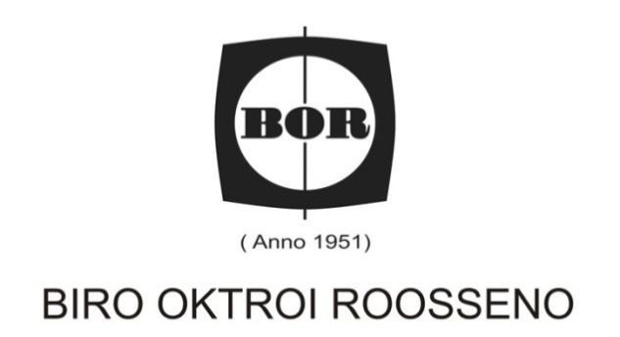
Phone No. : (62-21) 576 2310 (Hunting System)
Fax. No. :(62-21) 576 2301, (62-21) 576 2302,
eFax. No. : (65) 6826 4084
E-mail : iprlaw@iprbor.com
Website : www.iprbor.com

Kantor Taman A9, Unit C1 & C2
Jl. Dr. Ide Anak Agung Gde Agung (Mega Kuningan),
Jakarta 12950, Indonesia
P.O. Box 4585, Jakarta 10001

